# RGB Color Detector using RGB using TCS3200

Introduction

The light is detected by the photodiodes and the output is a frequency proportional to the current flowing through the photodiodes which is related to the filter used and the object’s color detected.

The **TCS3200 RGB Color Sensor For Arduino** has an array of photodetectors, each with either a red, green, or blue filter, or no filter (clear). The filters of each color are distributed evenly throughout the arra

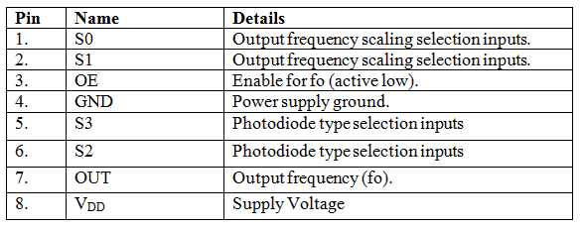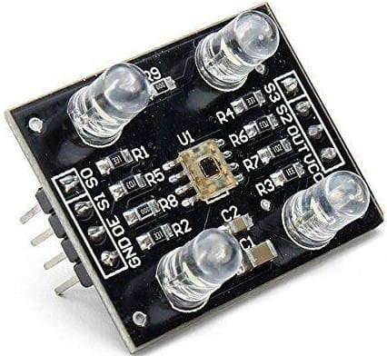

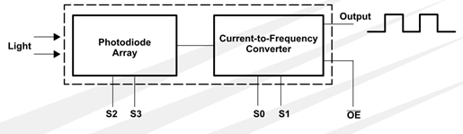

Components

**Hardware:**ARDUINO UNO, power supply (5v), LED, JHD_162ALCD (16*2LCD),TCS3200 color sensor.

ARDUINO IDE

Application

the textile industry, colour sensors can determine whether the colour of the manufactured fabrics match the reference

in the food industry, colour sensors are used for monitoring colour changes in FOOD packed

in automation industry

in pharmaceutical industry

Objective

During this activity ,you will help students to achieve following objectives

1. Understanding the principle and operation of TCS-230 colour sensor module
2. Design algorithm and flowchart for TCS-230 colour sensor module
3. Programming TCS-230 colour Sensor module using Arduino uno
4. Interfacing TCS-230 colour module withArduino uno

Programming steps

1. Include library for LCD
2. Initialize LCD pin
3. Initialisesensor input pin
4. Initialize variables for LEDS and pins for LEDS
5. Initialize setup for input and output port
6. Read sensor input value and intensity of color get
7. If intensity(red<blue) then display [RED LED] and make red LED on
8. If intensity(blue<red) then display [BLUE LED] and make blue LED on
9. If intensity( green<red) then display [GREEN LED] and make green LED on
10. Else display[CAN’T IDENTIFY]

Program

|  |
| --- |
| #include <LiquidCrystal.h>  LiquidCrystal lcd(7, 6, 5, 4, 3, 2);//RS,EN,D4,D5,D6,D7    const int s0 = 8;  const int s1 = 9;  const int s2 = 10;  const int s3 = 11;  const int out = 12;  // LED pins connected to Arduino  int redLed = 16;  int greenLed = 15;  int blueLed = 14;  // Variables  int red = 0;  int green = 0;  int blue = 0;    void setup()  {    Serial.begin(9600);    lcd.begin(16, 2);    pinMode(s0, OUTPUT);    pinMode(s1, OUTPUT);    pinMode(s2, OUTPUT);    pinMode(s3, OUTPUT);    pinMode(out, INPUT);    pinMode(redLed, OUTPUT);    pinMode(greenLed, OUTPUT);    pinMode(blueLed, OUTPUT);    digitalWrite(s0, HIGH);    digitalWrite(s1, HIGH);  }    void loop()  {     lcd.setCursor(0, 0);    lcd.print(" Color Detected ");//printing name    color();    Serial.print("R Intensity:");    Serial.print(red, DEC);    Serial.print(" G Intensity: ");    Serial.print(green, DEC);    Serial.print(" B Intensity : ");    Serial.print(blue, DEC);    //Serial.println();      if (red < blue && red < green && red < 20)    {     Serial.println(" - (Red Color)");      lcd.setCursor(0, 1);     lcd.print("    RED Color   ");     delay(500);     digitalWrite(redLed, HIGH); // Turn RED LED ON     digitalWrite(greenLed, LOW);     digitalWrite(blueLed, LOW);    }      else if (blue < red && blue < green)    {     Serial.println(" - (Blue Color)");     lcd.setCursor(0, 1);     lcd.print("   Blue Color   ") ;     delay(500);     digitalWrite(redLed, LOW);     digitalWrite(greenLed, LOW);     digitalWrite(blueLed, HIGH); // Turn BLUE LED ON    }      else if (green < red && green < blue)    {     Serial.println(" - (Green Color)");     lcd.setCursor(0, 1);     lcd.print("   Green Color   ");     delay(500);     digitalWrite(redLed, LOW);     digitalWrite(greenLed, HIGH); // Turn GREEN LED ON     digitalWrite(blueLed, LOW);    }    else{    Serial.println();    lcd.setCursor(0, 1);    lcd.print(" Can't Identify");    delay (500);    }    digitalWrite(redLed, LOW);    digitalWrite(greenLed, LOW);    digitalWrite(blueLed, LOW);  }    void color()  {    digitalWrite(s2, LOW);    digitalWrite(s3, LOW);    //count OUT, pRed, RED    red = pulseIn(out, digitalRead(out) == HIGH ? LOW : HIGH);    digitalWrite(s3, HIGH);    //count OUT, pBLUE, BLUE    blue = pulseIn(out, digitalRead(out) == HIGH ? LOW : HIGH);    digitalWrite(s2, HIGH);    //count OUT, pGreen, GREEN    green = pulseIn(out, digitalRead(out) == HIGH ? LOW : HIGH);  } |

Hardware

Instruction

1. Connect VSS and VEE pin of LCD to ground and VCC pin to 5v supply voltage pin of LCD
2. Connect enable pin to D6 and register select pin to D7
3. Connect R/W pin of LCD to ground
4. Connect data pin of LCD ( 2,3,4,5) to the D7,D6,D5,D4 pin of Arduino
5. Connect sensor VCC and GND pin to Arduino voltage pins
6. Connect sensors S0 to D8,S1 to D9,S2 to D10,S3 to D11
7. Connect OUT pin of sensor to D12
8. Connect LED 1 to analog input pin A0,LED2 to A1, LED3 to A2

